**BALI TOUR PACKAGE**

**4 DAYS 3 NIGHT**

**DAY 01. ARRIVAL – SOUTHERN BALI**

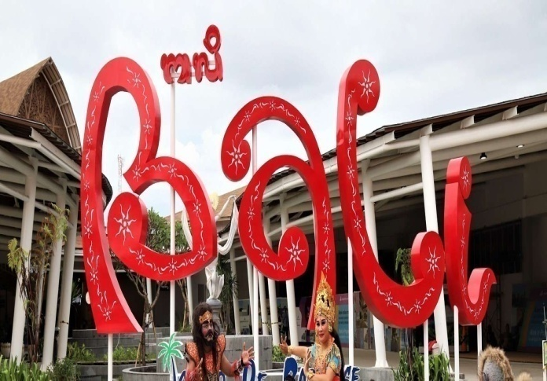  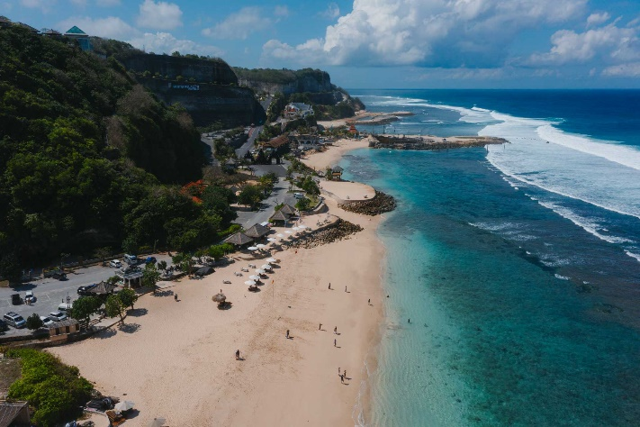

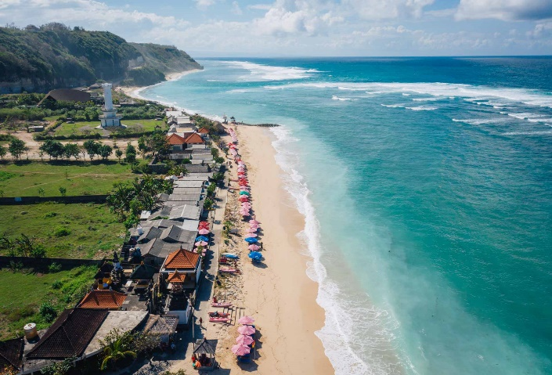 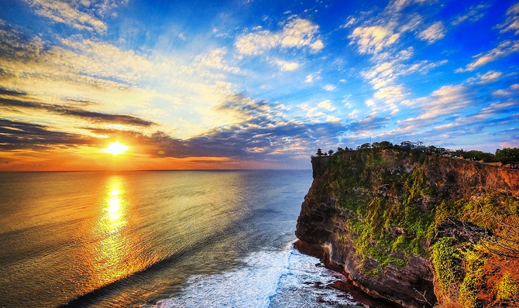

* Group is arriving at International Ngurah Rai airport of Bali
* Meet and greet with our tour guide.
* Lunch at local resto (Optional)
* Visit Melasti and Pandawa beach
* Beautiful sunset at Uluwatu temple
* Dinner at local resto (Optional)
* Check in hotel and take arrest

**DAY 2. BEDUGUL – TANAH LOT TOUR (B)**

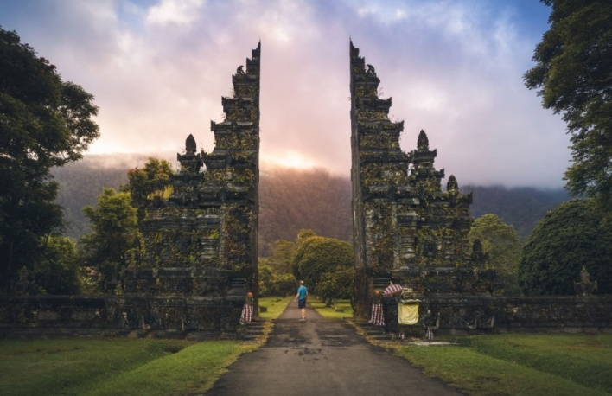 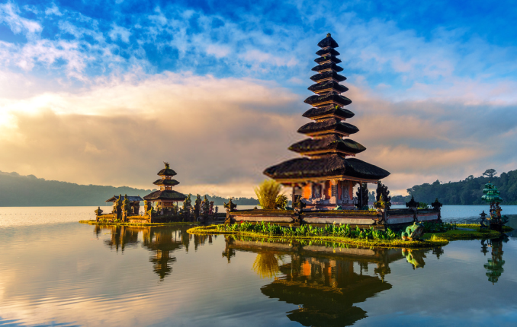

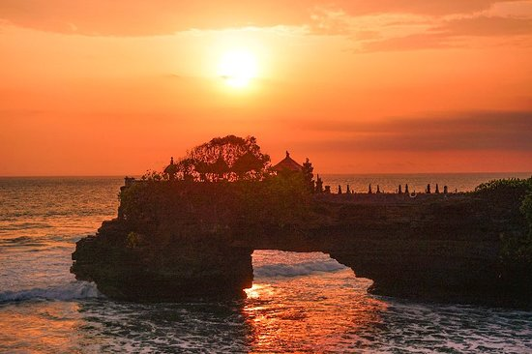 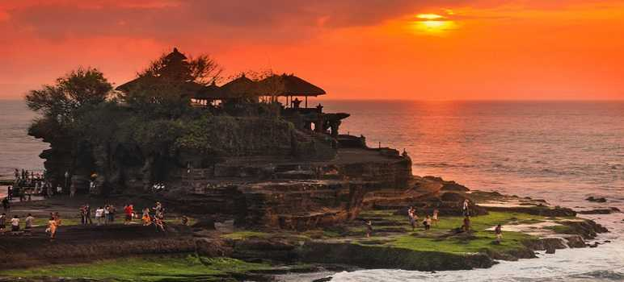

* Breakfast at hotel.
* Photo stop at Wanagiri Hidden Hill with beautiful twin lake (Buyan and Tamblingan lake)
* Then to Bedugul Mountain and tranquil Lake Beratan to see the beautiful view of Ulun Danu Temple.
* Lunch at local resto (Optional)
* Visit kopi Luwak / civet coffee farm in Luwus
* The last destination is Tanah Lot Temple, wonderful sunset expected here
* Dinner at local resto (Optional)
* Back to hotel and take a rest

**DAY 03. KINTAMANI TOUR (B)**

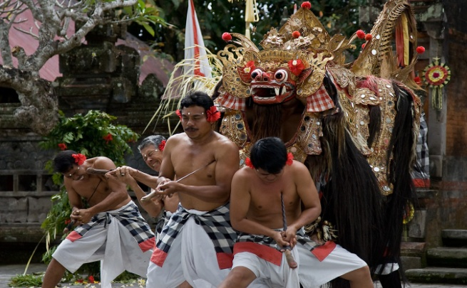 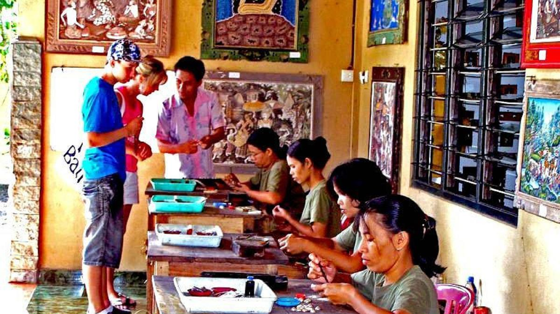

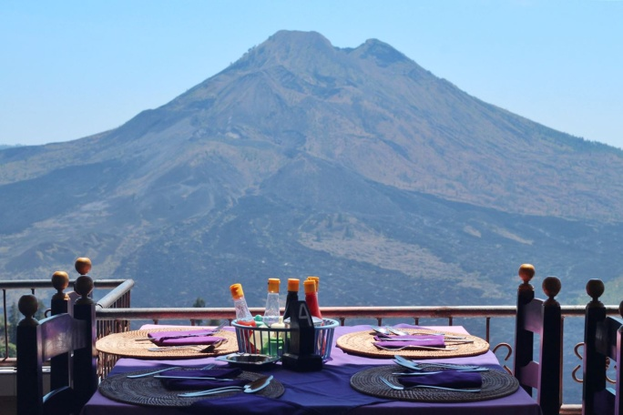 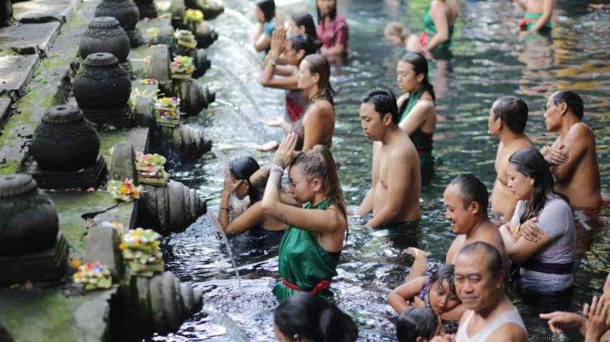

* After breakfast in Hotels Restaurant
* Direct proceed to watch the Barong and Keris Dance. Barong probably the most well-known traditional dance in Bali, narrating the fight between good and evil, Barong is a lion-like creature and character in the mythology of Bali.
* Visit Celuk village for traditional gold and silver art
* Visit Kintamani Village with Amazing Volcano view of Mount Batur and lake Batur
* Lunch at local resto (Optional)
* Continue the Tour visit Tirta Empul Temple, the holy spring water temple is built around the scared spring at Tampak Siring.
* Dinner serves at local resto (Optional)
* Back to hotel and take a rest

**DAY 04. SHOPPING – AIRPORT (B)**

* Breakfast at hotel
* Check out and return room keys.
* Shopping for souvenirs at Krisna Oleh-Oleh
* Heading to airport of Ngurah Rai transfer out to next destination

**RATE IDR/NETT/ 1 PERSON**

|  |  |  |  |
| --- | --- | --- | --- |
| **NO** | **HOTEL** | **STAR** | **RATE IDR 1 PERSON** |
| **1** | **SWISS BELEXPRESS KUTA** | **3\*** | **4,028.000** |
| **2** | **NEO + KUTA HOTEL** | **3\*** | **4,268.000** |
| **3** | **J4 LEGIAN HOTEL** | **4\*** | **4,328.000** |
| **3** | **RAMAYANA SUITE & RESORT** | **4\*** | **5,528.000** |

***High Season Surcharge IDR 200,000 net/night stay on 1st July until 31st August 2023***

**INCLUDING:**

* Accommodation hotel as listed, 1 room with 2 persons. An extra bed for 3rd person
* Private transportation with driver and petrol
* Breakfast only
* Watching Barong and keris dance
* Mineral water 2btl/day
* Entrance fee & Donation
* Toll & parking fee

**EXCLUDED:**

* Airplane ticket
* Tour guide
* Meal program Lunch and Dinner

**PACKGE CONDITION:**

For hotels outside the list, please contact us.

The package is valid for Asian citizens for a minimum of 1 pax

The fleet used is avanza / Isuzu elf according to the number of participants

There are no ticket & hotel bookings yet, changes can occur at any time according to the availability of airplane seats/hotel rooms during reservation

Packages are private (not combined with other guests)

*For children aged 3-12 years, 50% sharing bed & 75% with extra bed will be charged, while for Toddlers 0-2 years, Free of Charge*

**HOTEL INFORMATION**

1. **SWISS BELEXPRESS KUTA LEGIAN**

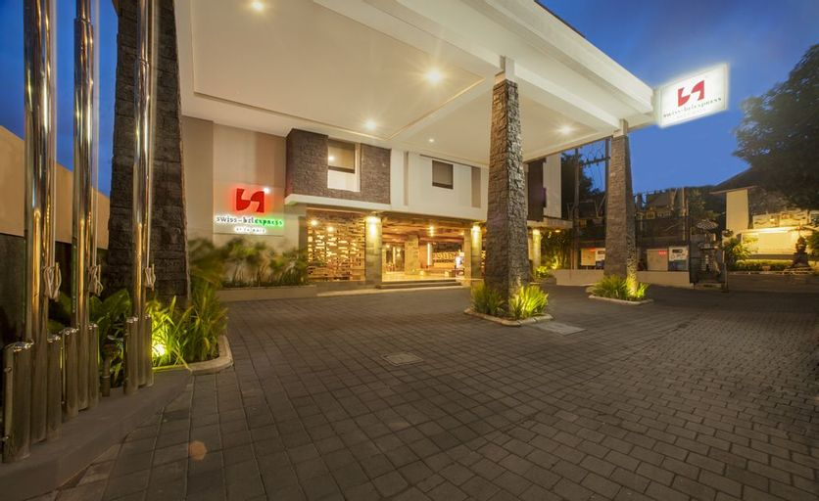 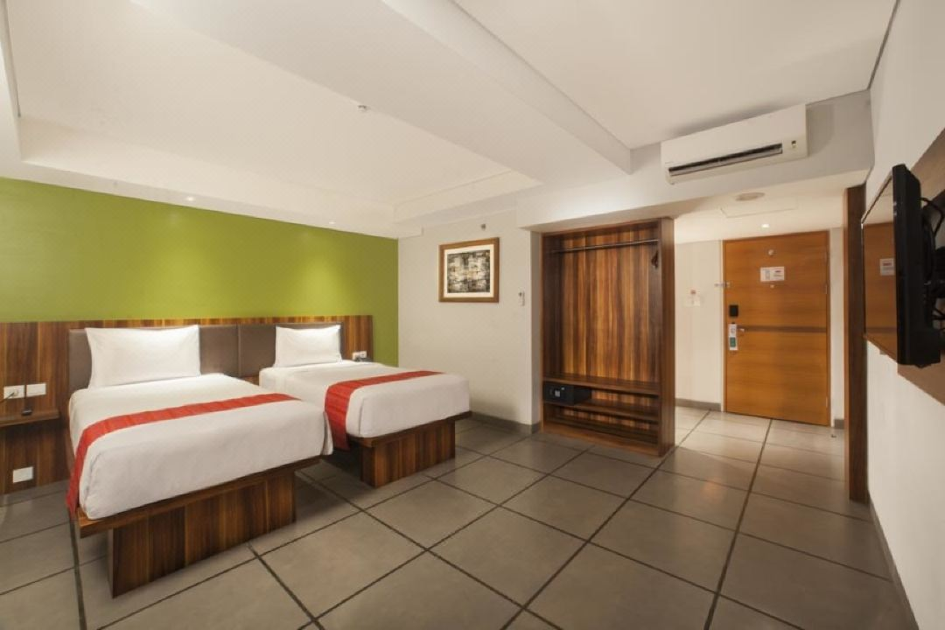

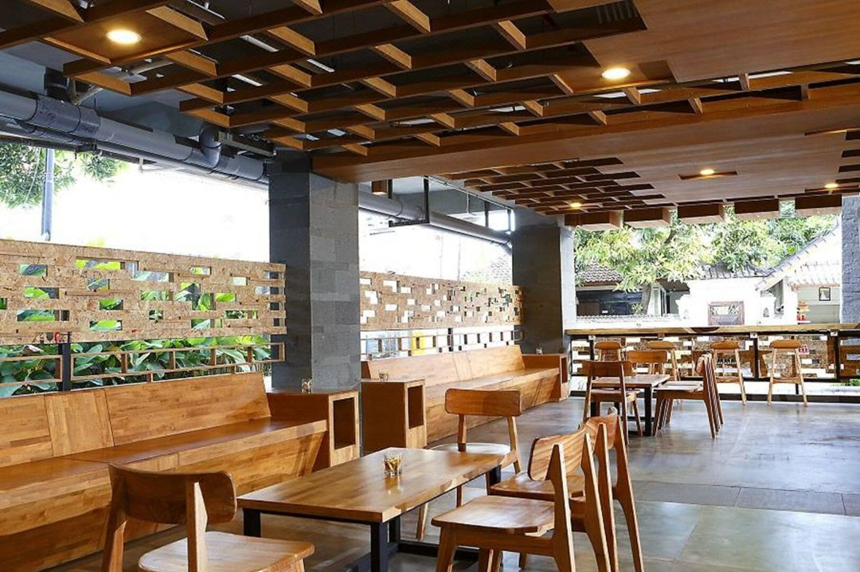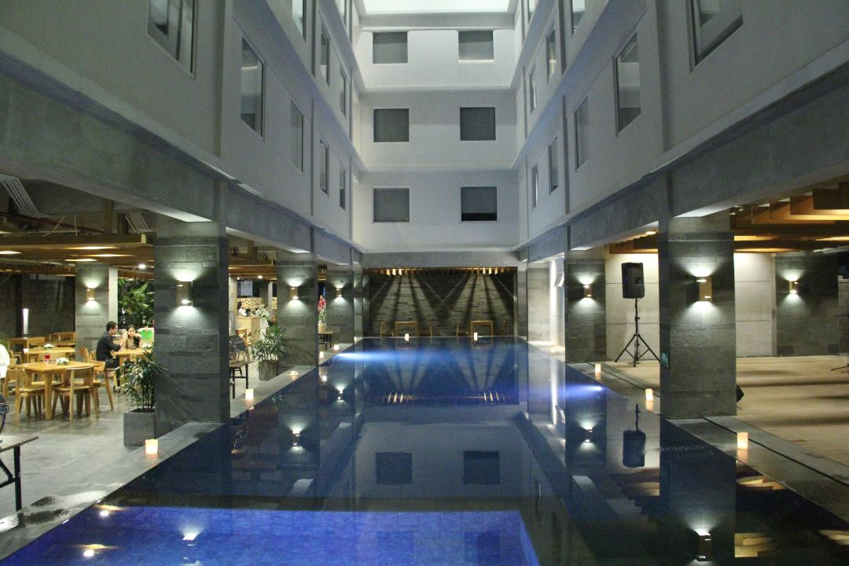

1. **HOTEL NEO+ KUTA**

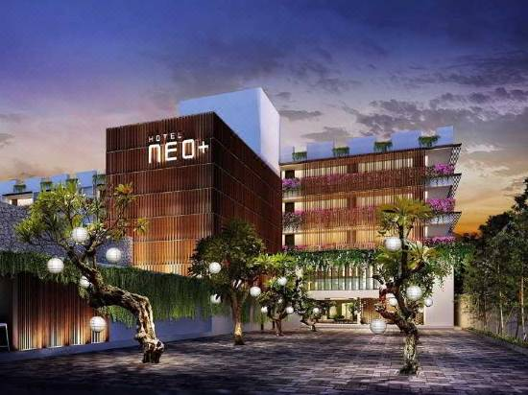 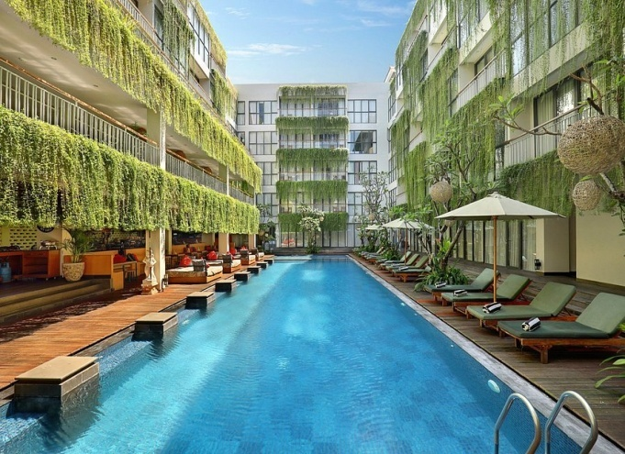

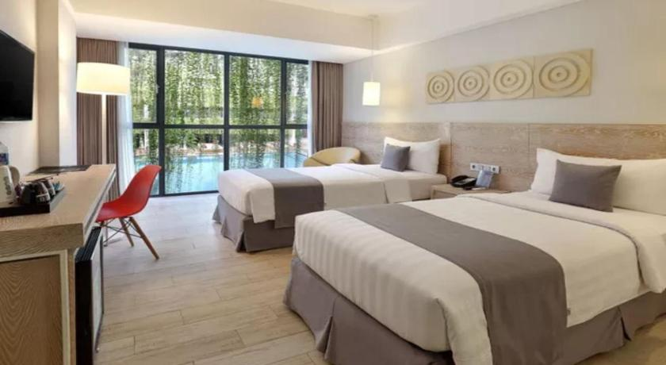 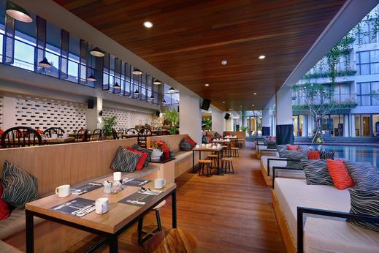

1. **J4 HOTEL LEGIAN**

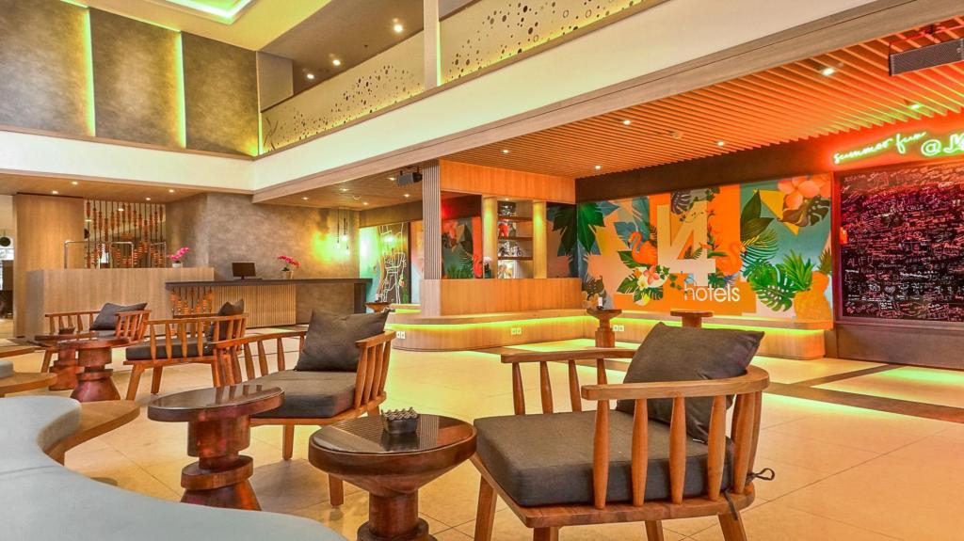 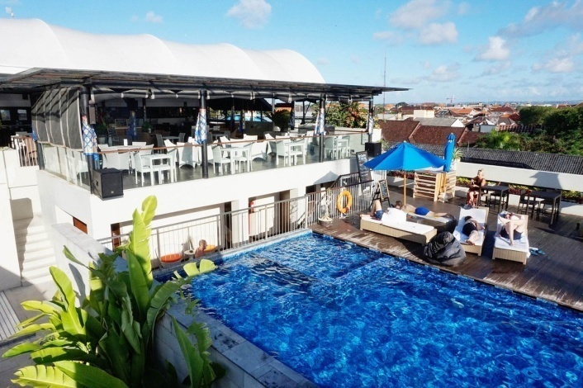

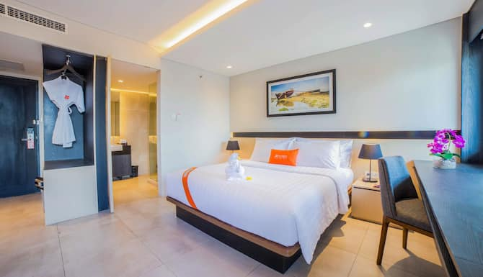 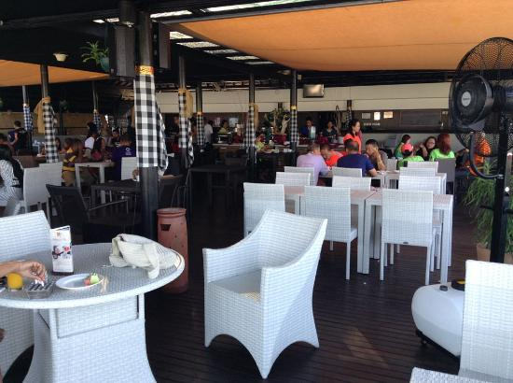

1. **RAMAYANA SUITE & RESORT**

